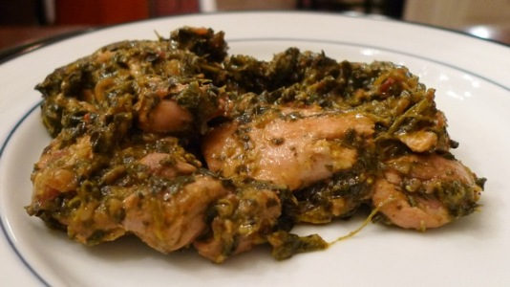

**Palak Chicken**

**Recipe Ingredients:**

* 3-4 tablespoons ghee (clarified butter)
* 3 onions, chopped
* ½ teaspoon turmeric
* Salt
* 1-2 teaspoons red chilli powder
* 3 teaspoons fresh ginger, finely chopped
* 1 teaspoon crushed garlic
* 8 cloves
* 4 bunches spinach, chopped
* 2 bunches methi (fenugreek leaves) optional
* 1 teaspoon cummin
* 6 tomatoes, chopped
* 1 chicken, cut into pieces
* 250-500 ml or 1-2 cups water
* 1 teaspoon garam masala

**Recipe Method:**

1. Melt ghee in a large frying pan. When hot, add onions and turmeric. Sauté until onions are light brown. Add salt, chilli powder, ginger, garlic and cloves. Stir in 3 minutes. Add spinach, methi, cummin and tomatoes. Stir until ingredients soften into a rich sauce. Add chicken and stir. Add water, cover and simmer until chicken is cooked. Just before serving, add garam masala.